__________________________________________________________________________

**SCHOOL OF ENGINEERING AND TECHNOLOGY**

**ASSESSMENT FOR THE MASTER OF DATA SCIENCE**

|  |  |  |
| --- | --- | --- |
| **SUBJECT CODE AND TITLE:** | | **MDM5053 BIG DATA MANAGEMENT** |
| **ASSESSMENT DUE DATE:** | | **10/12/2024** |
| **NO.** | **STUDENT ID** | **STUDENT NAME** |
| **1** | **14086334** | **KAN JUN FAI** |

# 

**IMPORTANT**

# The University requires students to adhere to submission deadlines for any form of assessment. Penalties are applied in relation to unauthorised late submission of work. Coursework submitted after the deadline will be subjected to the prevailing academic regulations. Please check your respective programme handbook.

**Academic Honesty Acknowledgement**

“I **KAN JUN FAI** (name) verify that this paper contains entirely my own work. I have not consulted with any outside person or materials other than what was specified (an interviewee, for example) in the assignment or the syllabus requirements. Further, I have not copied or inadvertently copied ideas, sentences, or paragraphs from another student. I realise the penalties *(refer to the student handbook and undergraduate programme handbook)* for any kind of copying or collaboration.”

……………………….................................... (Student’ Signature / Initial)

**Dataset Use Case and the Problems:**

[The Spotify dataset from Kaggle](https://www.kaggle.com/datasets/refiaozturk/spotify-songs-dataset/data) was used in our music streaming company simulation, with 50000 records of AI-generated records containing song titles, artist names, genres, (all features shown in image below). The key insights collected through analyzing this dataset using MySQL uncovered success factors of the music streaming industry by examining key features like the average total streams, genre, and release year. However, as the music industry grows, there are massive amounts of user data waiting to be analysed to in order to uncover insights on user preferences, content preferences, and user engagement. There is a growing challenge of effectively analyzing large scale datasets and extracting business insights in a time-efficient manner in this fast-paced digital world. Conventional methods like MySQL face performance challenges in handling large datasets. With the implementation of Big Data tools like PySpark, this project will aim to compare the performance of using MySQL vs. PySpark, in terms of handling large-scale business insights in the most efficient and effective method. The insights gathered will provide the potential advantages of implementing Big Data tools in Big Data management of companies to improve business analytics, leading to improved customer engagement and business growth.

**Comparing techniques of Conventional (MySQL) vs Big Data (PySpark)**

**MySQL**

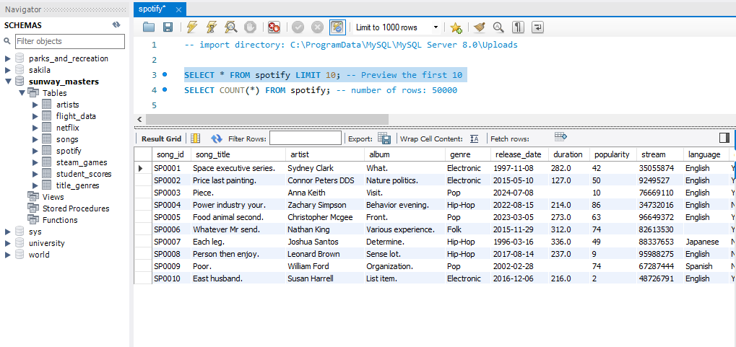

The query above prints the first 10 records out of a total of 50,000 records.

The above query is written such that if there are NULL values in each column, the table will return ‘1’ , and ‘0’ when there is no NULL values found. No null values were recorded.

1. Total streams per genre

The query code above queries for the total streams per genre, grouped by genre and sorted the total streams according to descending order. By interpreting the results, ‘Electronic’, ‘Pop’, and ‘Hip-Hop’ represents the top three most popular genres as they dominate the other genres by an overwhelming amount, followed by ‘Folk’, ‘Classical’, ‘Country’, and ‘Jazz’, and lastly ‘R&B’ and ‘Reggae’. This pattern is likely due to the high number of released songs based on modern-day trend containing electronic, pop, and hip-hop genres, attracting consumption by global consumers which indicate global appeal. As for business insights obtained from this query, businesses can utilize electronic, pop, and hip-hop genre songs to be utilized in advertisements, radio, and events to attract and funnel attention towards targeted content/advertisements. For Spotify as a streaming platform, content recommendations may be directed towards playlists containing Folk, Classical, Country, Jazz, R&B and Reggae may be encouraged to attract new listeners towards the mentioned genres.

1. Total streams per ‘release_year’

The query code above has two parts. First, a new column “release_year” was created and added to the spotify table. Secondly, the query then selects for total streams grouped by release year and sorted according to ascending release year. Based on analyzing the volume of streams per year, there is an overall high usage rate of music streaming platforms like Spotify due to the internet boom in 2000s. Since this dataset does not have streaming volume according to varying timestamps, time-series data analysis is not conclusive.

1. Average streams per genre

The query above queries for average number of streams for each genre, sorted according to descending order of highest to lowest average streams per genre. Reggae, R&B, and Folk are the top three highest streamed genres. Electronic, Pop, and Hip-Hop – where they previously dominate in total streams per genre – are now in the lower performing genres according to average streams. Electronic, Pop, and Hip-Hop may possibly contain a number of songs that are less popular and less streamed, lowering the average score of these genres.

1. Combination of genre and ‘release_year’

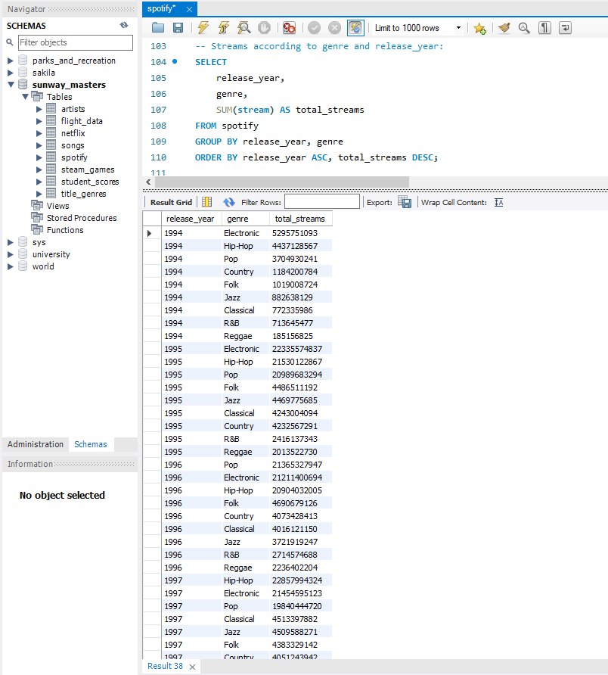

The query above calculates the total number of streams for the combination of release year and genre, sorted in chronological order starting in 1994 to 2024. For each year, the most streamed genre will be the first mentioned (Please see Appendix on last page for full table). Electronic genre is observed to be consistently rank in the top three genres in many years, suggesting genre dominance, popularity, and global appeal. Business insights for music streaming platforms include themed playlist suggestions to improve user retention rate, and cross-recommendation on niche or less-played songs to introduce less popular songs to new audiences.

**PySpark**

1. Total streams per genre

1. Total streams per ‘release_year’

1. Average streams per genre

1. Combination of genre and ‘release_year’

**Discussion**

The main comparisons to be discussed between MySQL vs. PySpark are the handling of dataset sizes, performance, and scalability, and use-cases. In terms of handling dataset sizes, PySpark is able to manage large datasets with ease, whereas MySQL is more suited for smaller datasets. In terms of performance, MySQL was a few seconds slower than PySpark when handling compute-intensive tasks, whereas PySpark was performing optimally with close to no delay in response. While MySQL has restricted scalability, PySpark's scalability is excellent due to its ability to handle heavy compute tasks. Lastly in terms of use cases, MySQL is useful is smaller datasets and is more conventional in its querying rules. Conversely when using PySpark, similar concept but different language is used compared to MySQL, which requires a strong foundation in coding knowledge in order to effectively utilize PySpark to its full potential. Overall, PySpark is useful in handling massive datasets, providing the ability to perform efficient business analytics. MySQL is excellent at handling smaller structured datasets; however the challenge arises when the data volume increases.

**Reflection on the Lessons Learned:**

Through the understanding of the listener’s content preferences by analysing the seasonal trends of trending genres. Through personalized recommendations, Spotify can tailor and recommend themed playlists like “Back to 2000s”, “Electronic Era”, making use of nostalgia in order to boost user engagement. Personalized user experiences contribute to longer content engagement time, providing opportunity to boost the reach of less popular songs to users via song discovery. Advertisers may leverage on trends to promote merchandise relating to certain theme of music, further encouraging user engagement.

As the volume of user generated data increases, the challenge comes in how to effectively and efficiently process a massive amount of data in real-time to extract and make use of business insights. Big Data management tools provide the solution to efficiently compile, extract and perform business analytics when data volume is immense. The Big Data tool used is PySpark, while the conventional tool used is MySQL. PySpark can handle large datasets with ease, while MySQL is better suited for smaller datasets. Performance-wise, PySpark outperforms MySQL in compute-intensive tasks, providing near-instantaneous responses, whereas MySQL experiences slight task processing time. Scalability is another key distinction; PySpark offers optimal scalability for heavy compute tasks, while MySQL very much limited. For use cases, MySQL is suitable for handling smaller, structured datasets with conventional querying methods. PySpark, on the other hand, demands solid coding knowledge for processing massive datasets and performing advanced business analytics. Overall, PySpark is best for large-scale data handling, while MySQL is optimized with smaller datasets but struggles as data volume increases.